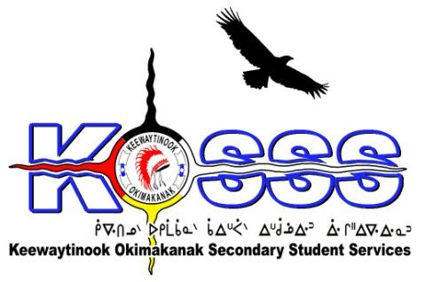
KEEWAYTINOOK OKIMAKANAK SECONDARY
STUDENT SERVICES (KOSSS)
1046 Memorial Avenue
Thunder Bay, Ontario P7B 4A3
Phone: (807) 346-4204 Ext. 1709
Fax: (807) 346-4330
Toll Free: 1-888-893-4111

Keewaytinook Okimakanak Secondary Student Services
Health & Wellness Coordinator Required- One year Contract with Benefits and the Possibility of Extension

Keewaytinook Okimakanak Secondary Student Services (KOSSS) is seeking one (1) full-time Health & Wellness Coordinator. The position will be based in Thunder Bay and will begin January 2017 and extend to March 2019.
The KOSSS Health & Wellness Coordinator will coordinate services and support the KOSSS student mental health team to ensure proper case management, tracking of specialized service requests and program reporting requirements. The Health & Wellness coordinator would also track any service gaps relevant to the delivery of Jordan’s Principle funding and would work with the Mental Health Workers (MHWs) and KOSSS/KO Management and Staff to minimize gaps and improve overall services. The Health & Wellness Coordinator would work with the First Nations and Community Mental Health workers to identify a transition plan for students who return to their home communities.

The following are the requirements for this position:
Qualifications
- education related work experience
- Bachelor’s Degree or Equivalent Experience and training or education-related position
- Knowledge of First Nation education & health issues, challenges, and delivery models
- Knowledge of the Jordan’s Principle Initiative and or willing to learn
- Ability to speak one of the local dialects is an asset
- Strong Interpersonal Skills
- Valid Class G Driver’s License
- Must be willing to provide a police criminal background check
- Able to work effectively with others
- Ability to work independently
- Strong communication skills with proficiency in developing written communications and the development and delivery of oral presentations

Duties will include, but may not be limited to:

The Health and Well-Being Coordinator will take direction from the KOSSS Education Coordinator and KOBE.

- Coordination of meetings, travel, reporting, training and development of materials related to Jordan’s Principle and the KOSSS Mental Health Team;
- Liaison and sharing of information with the KOSSS Education Staff, KOBE Board of Directors and KO First Nations;
- Track and record service gaps and successes;
- Travel to the Keewaytinook Okimakanak communities: Deer Lake, Fort Severn, Keewaywin, McDowell Lake, North Spirit Lake and Poplar Hill First Nations;
- Other related duties as set by the KO Board of Education and KOSSS

Salary will be based on a combination of qualifications and experience.

Deadline: Tuesday January 8, 2018 by 1:00 P.M. EST

FAX: 1.807.346.4330
Email: Resumes to: henryowusu@edu.knet.ca

