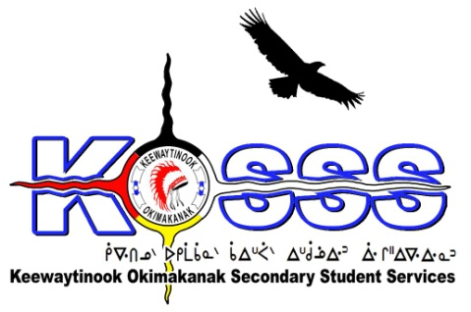
KEEWAYTINOOK OKIMAKANAK SECONDARY
STUDENT SERVICES (KOSSS)
1046 Memorial Avenue
Thunder Bay, Ontario P7B 4A3
Phone: (807) 346-4204 Ext. 1709
Fax: (807) 346-4330
Toll Free: 1-888-893-4111

Keewaytinook Okimakanak Secondary Student Services
Well-Being Worker Required- One year Contract with Benefits and the Possibility of Extension

Keewaytinook Okimakanak Secondary Student Services is looking to fill five (5) full-time Well-Being Worker positions from January 2017 to March 2019. This position will be based in: Pelican Falls (2), Dryden (1), Sioux Lookout (1) and Thunder Bay (1).

The KOSSS Well-Being Worker would work and support the KOSSS well-being program area in their day-to-day case management and support to students. The Well-Being Worker would assist the Well Being Team in identifying any service gaps and assist the KOSSS Well Being Team in the development of programming and supports that would address these needs.

Duties and Responsibilities:
- Assist the KOSSS Well Being Team in the development of health & well-being programming and activities that would be appropriate for youth aged 13 through 20 years.
- Assist in the transportation and care of students while receiving services, aide or participating in programming.
- Assist the KOSSS Well Being Team and Student Support Workers in providing support to students on a daily basis.
- Participate in programming that would build stronger connections and supports to KOSSS Students i.e. Camping trips, Rabbit Snaring, Lunch and Learn Workshops, etc.
- Other duties that will be assigned by the KOSSS Well Being Team and KOSSS Coordinator.

Qualifications:
- Related work experience
- College Diploma or Equivalent Experience and training or education-related position
- Knowledge of First Nation education issues, challenges, and delivery models
- Ability to speak one of the local dialects is an asset
- Strong Interpersonal Skills
- Valid Class G Driver’s License
- Must be willing to provide a police criminal background check
- Able to work effectively with others
- Ability to work independently
- Strong communication skills with proficiency in developing written communications and the development and delivery of oral presentations
- Willing to travel to the KO communities: Deer Lake, Fort Severn, Keewaywin, McDowell Lake, North Spirit Lake and Poplar Hill

Salary will be based on a combination of qualifications and experience.

Deadline for the above Position is: January 8, 2017 by 1:00 P.M. CST

Please FAX or E-Mail Resumes to: 1-807-346-4330 or email to henryowusu@edu.knet.ca

