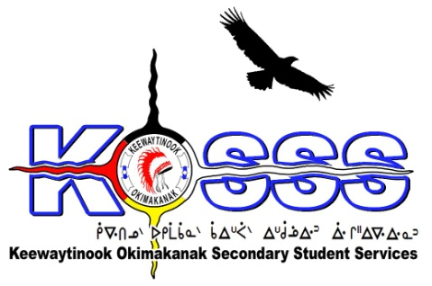
KEEWAYTINOOK OKIMAKANAK SECONDARY
STUDENT SERVICES (KOSSS)
1046 Memorial Avenue
Thunder Bay, Ontario P7B 4A3
Phone: (807) 346-4204 Ext. 1709
Fax: (807) 346-4330
Toll Free: 1-888-893-4111

Keewaytinook Okimakanak Secondary Student Services
Land-Based Coordinator Worker Required

Keewaytinook Okimakanak Secondary Student Services is looking to fill one Land-Based Worker Position. The Land-Based Worker will work out of Thunder Bay, Ontario and will commence in September 2017. The grade 9-12 students will be coming from our First Nation communities of Fort Severn, Keewaywin, Deer Lake, North Spirit Lake,Poplar Hill, and McDowell Lake.

The following are the requirements for this position:

Qualifications

- Degree or training in education-related fields
- Experience working in the education field and land based activities is an asset
- Knowledge and understanding of Aboriginal culture and values
- Experience in utilization of Traditional Ecological knowledge or cultural knowledge within education related fields
- Experience developing and delivering educational programming, specifically in land-based learning activities
- Creating, using and evaluating personalized teaching tools and techniques used in outdoor experiential education and cultural education activities
- Excellent leadership, management, motivation and problem-solving skills
- Ability to speak one of the local dialects is an asset
- Strong Interpersonal Skills
- Valid Class G Driver’s License and willing to obtain class “E”
- Must be willing to provide a police criminal background check
- Able to work effectively and collaboratively with others
- Ability to work independently
- Strong communication skills with proficiency in developing written reports, documents, and the development and delivery of oral presentations
- Pleasure Craft Boaters License or willing to obtain it
- Fire Arms Certification will be an asset and or willing to obtain it

Duties will include, but may not be limited to:

- Lead experimental, land based activities
- Develop curriculum and or programming that is based on the cultural land based program, and connections to the land
- Incorporate land based practices, protocols and the relationship to First Nation peoples’ identities and ways of life that will promote identity and culture
- Travel with students to land-based programming sites and to KO First Nations
- Other duties related to the KOSSS education as set by the KO Board of Education
- Take training related to position, i.e. First Aid/CPR
- Maintaining Land-Based Equipment and keep inventory
- Involve elders for guidance and direction

Salary will be based on a combination of qualifications and experience.

Deadline for the above Position is: August 28, 2017 by 1:00 P.M. CST

Please FAX or E-Mail Resumes to: 1-807-346-4330 or email to henryowusu@edu.knet.ca

