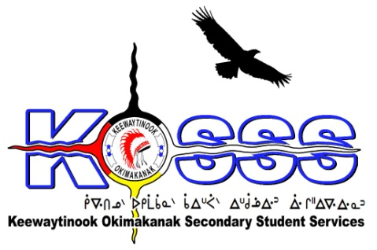
KEEWAYTINOOK OKIMAKANAK SECONDARY
STUDENT SERVICES (KOSSS)
1046 Memorial Avenue
Thunder Bay, Ontario P7B 4A3
Phone: (807) 346-4204 Ext. 1709
Fax: (807) 346-4330
Toll Free: 1-888-893-4111

Keewaytinook Okimakanak Secondary Student Services
Student Support Worker Required

Keewaytinook Okimakanak Secondary Student Services is looking to fill one Student Support Worker Position. The Student Support Worker will work out of Thunder Bay, Ontario and will commence in October 2017. The grade 9-12 students are from our First Nation communities of Fort Severn, Keewaywin, Deer Lake, North Spirit Lake,Poplar Hill, and McDowell Lake.

KOSSS Student Support Worker should possess:

Qualifications
- Must have training in Education/Teaching/ or Social Work background or related fields (Degree/Diploma will be an asset)
- High expectations for all students
- Familiarity with First Nation Culture, especially with KO First Nations
- Ability to speak one of the local dialects is an asset
- Valid class G Driver’s License
- Must be willing to provide a criminal record check
- Must have computation skills

Desired Experience
- Knowledge of child development—specifically of physical, emotional, and developmental patterns
- A team player with experience working in a collaborative environment
- Professional manner and appearance
- Ability to listen to and communicate with parents and see parents as a resource
- Possesses conflict resolution skills
- Is patient and caring
- Demonstrate effectiveness in personal and office management skills
- Uses good organizational skills to meet the needs of the students
- Believes successful learning comes from a collaboration between all student service providers
- Is capable of working with small and large groups of students
- Experience in school and counseling environments
- Willing to work beyond working hours
- Ability to use computer programs and compile reports
- Willing to learn and to adapt to new programs and approaches under KOSSS program

Duties will include, but may not be limited to:

- Transport student to appointments, school, airport, and other
- Plan and provide support for implementing KOSSS extra-curricular activities
- Supervise and monitor students attendance, academic progress, and behavior
- Implement and plan student case conferences
- Encourage and support Student academic tutoring sessions
- Recruit, Screen, and support Boarding Homes/parents
- Provide emergency assistance and support for Students, Parents, and Boarding homes.
- Travel within KOSSS communities and KOSSS student sites when needed.
- Adhere to KOSSS/KOBE policy and procedures
- Adhere to Student Support Worker job description

Salary will be based on a combination of qualifications and experience.

Deadline for the above Position is: September 25, 2017 by 1:00 P.M. CST

Please FAX or E-Mail Resumes to: 1-807-346-4330 or email to henryowusu@edu.knet.ca

