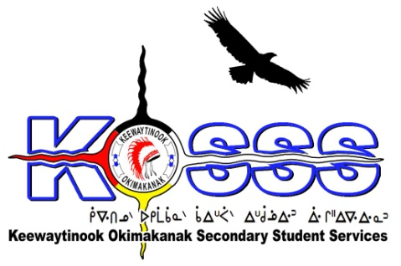
KEEWAYTINOOK OKIMAKANAK SECONDARY
STUDENT SERVICES (KOSSS)
1046 Memorial Avenue
Thunder Bay, Ontario P7B 4A3
Phone: (807) 346-4204 Ext. 1709
Fax: (807) 346-4330
Toll Free: 1-888-893-4111

Keewaytinook Okimakanak Secondary Student Services
KOSSS Student Support Worker Required-Contract Term
Keewaytinook Okimakanak Secondary Student Services is looking to fill one Student Support Worker position. The Student Support Worker will work out of Sioux Lookout, Ontario and will commence in January 2017 and end June 2017. The grade 9-12 students will be coming from our First Nation communities of Fort Severn, Keewaywin, Deer Lake, North Spirit Lake, Poplar Hill, and McDowell Lake.

KOSSS Student Support Worker should possess:

Qualifications
- Training in Education/Teaching/ or Social Work background preferred (Degree/Diploma will be an asset)
- High expectations for all students
- Familiarity with First Nations Culture
- Ability to speak one of the local dialects is an asset
- Valid class G Driver’s License
- Must be willing to provide a police criminal record check
- Must have computer skills

Desired Experience
- Knowledge of child development—specifically: physical, emotional, and developmental patterns
- A team player with experience working in a collaborative environment
- Professional manner and appearance
- Ability to listen to and communicate with parents and value parents as a resource
- Possesses conflict resolution skills
- Is patient and caring
- Demonstrates effectiveness in personal and office management skills
- Uses good organizational skills to meet the needs of students and parents
- Is capable of working with small and large groups of students
- Has experience in counseling students
- Willing to work beyond regular hours
- Willing to learn and to adapt to new programs and approaches under KOSSS

Duties will include, but may not be limited to:

- Transport student to appointments, school, airport, and other
- Plan and provide support for implementing KOSSS extra-curricular activities
- Supervise and monitor students attendance, academic progress, and behavior
- Implement and plan student case conferences
- Encourage and support Student academic tutoring sessions
- Recruit, Screen, and support Boarding Homes/parents
- Provide emergency assistance and support for Students, Parents, and Boarding homes
- Travel within KOSSS communities and KOSSS student sites when needed
- Participate in training and workshops when requested
- Adhere to KOSSS;s policies and procedures

Hourly Wage will be based on a combination of qualifications and experience.

Deadline for the above Position is: January 20, 2017 by 1:00 P.M. CST

Please FAX or E-Mail Resumes to: 1-807-346-4330 or email to henryowusu@knet.ca

